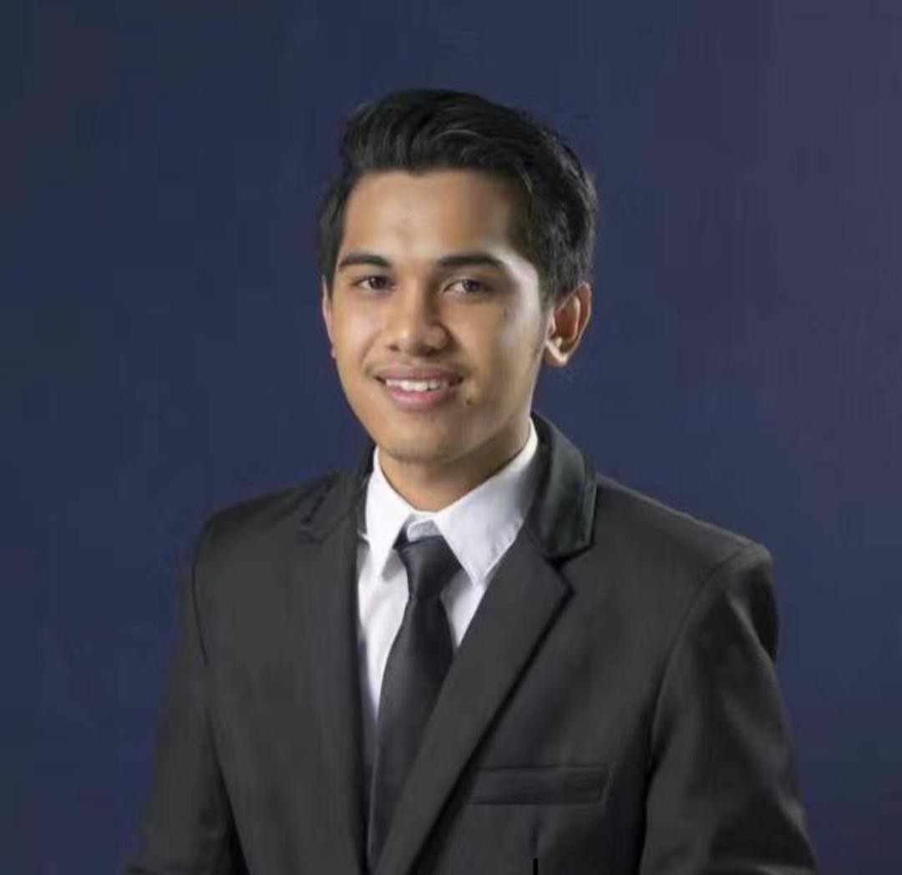
AFFIQFUDDIN BIN ZAM-ZAMI
Dedicated and results-driven professional with a diverse background in operational roles across multiple industries. With a solid foundation in machinery operation, maintenance, and repair, coupled with leadership experience, I have consistently demonstrated a proactive approach to problem-solving and a strong commitment to excellence in all endeavors.

BACKGROUND INFORMATION
Full Name : Affiqfuddin Bin Zam- Zami
NRIC : 980802-13-5633
Phone Number : 0111-6087088
Email : affiqfuddin98@gmail.com
Address : 501-A ,Kampung Tabuan Hilir, Jalan Setia Raja,
93450,Kuching Sarawak

WORKING EXPERIENCE

- Lead OPERATOR Longi Technology (Disember 2019-Until Now)
- Problem Resolution and Cost Savings: Played a pivotal role in troubleshooting and resolving critical machinery issues, demonstrating quick thinking and effective problem-solving skills.
- Adherence to Safety Protocols: Diligently adhere to company safety regulations and protocols, prioritizing the well-being of myself and fellow colleagues.
- Leadership and Auditing: As a leader within the operational team, I have taken on the role of a screen auditor for screening activities. This involves overseeing and auditing screening processes to ensure compliance with quality standards and operational protocols.
- Tool Operation and Productivity Enhancement: Skilled in the operation of various tools essential to manufacturing processes, demonstrating a keen understanding of tool functionality and utilization.
- Machinery Installation and Maintenance: Proficient in assisting with the installation of machinery and performing routine maintenance tasks to uphold operational continuity.
- Maintaining quality control measures and optimizing screening efficiency.

Achievement: Top Leader Recognition (2023)
Recognized for demonstrating exceptional leadership qualities, fostering teamwork, and driving success within the operational department.

- DISPATCHER J&T Express Kuching (Mei 2019-Disember 2019)
- Proficient in tracking the lifecycle of orders, from the moment they were placed to their final delivery.
- Utilized tracking systems and software to monitor order progress and maintain accurate records of delivery status.
- Demonstrated proficiency in handling parcel deliveries, ensuring prompt and secure transportation of packages to designated delivery locations.
- Demonstrated outstanding organizational skills in managing high volumes of parcel deliveries during peak periods, maintaining efficiency and quality standards under pressure.

- PERSONAL ASSISTANT Wisma Prudential Kuching ( Nov 2017-April 2018)
- Proficient in handling incoming correspondence, including emails, letters, and phone calls, promptly responding to inquiries and prioritizing messages based on urgency and importance.
- Skillfully organized meetings and appointments, liaising with internal and external stakeholders to schedule meetings, reserve venues, and prepare necessary documentation.
- Provided comprehensive administrative support, including preparing reports, drafting correspondence, and managing travel arrangements.
- Demonstrated proficiency in office management tasks, such as maintaining office supplies, coordinating office equipment maintenance, and processing expenses.

EDUCATION

KUCHING VOCATIONAL COLLEGE, 2016-2018
Diploma in Business Management PNGKA (Academic) 3.05
PNGKV (Vocasional) 3.47

KUCHING VOCATIONAL COLLEGE, 2014-2015
Vocational Certificate (Business Management)

PERSONAL QUALITIES
- Highly organized, hard-working and able to give a full commitment when working in a team.
- Able to write and speak fluently in Malay and English.
- Excellent interpersonal and teamwork skills
- Willing to work as a full timer and travel outstation
- Able to work and committed independently

REFERENCES

MR TING KEE HOU
(Manufactaring Engineering)

Address: Lot 2118, Jalan Usaha Jaya, Samajaya Free industrial,93450,Kuching, Sarawak

Phone Number: 010-9826435

